Report

Milestone 4 - Wireframing, Digital Information Architecture, and Interactive Low-Fidelity Figma Prototype

Team Phyvve
Annette Rodriguez, Arlena Ung
Emanuel Orduna-Chin, Sophia Ngo, Danny Lo
Professor: Fahd Albinali, PhD
California State University, Long Beach
College of Engineering
CECS 491A, Sec 03, Spring 2026

Table of Contents
Milestone 4 - Wireframing, Digital Information Architecture, and Interactive Low-Fidelity Figma Prototype 1
Table of Contents 2
Introduction 3
Target Audience and User Needs 3
Wireframes Evaluation and Design Selection 4
Application Structure and User Flow 5
Rationale for Features 5
1. Voice-Based Mock Interviews 5
3. AI-Powered Follow-Up Questions 6
4. Real-Time Feedback with Filler Word Detection and Delivery Analysis 6
5. Resume Integration and Personalized Question Generation 7
Conclusion 7

Digital Information Architecture
Low Fidelity Wireframes

Introduction
Interview Bot is an AI-powered interview preparation platform designed to help job seekers at all experience levels build confidence, sharpen communication, and succeed in competitive hiring processes. This report documents the rationale behind the features selected for the initial release, grounding each decision in user research, usability principles, and current trends in the career technology market. The features chosen represent a cohesive, user-centered product strategy that prioritizes accessibility for entry-level candidates while offering depth for experienced professionals. Each feature reflects a deliberate tradeoff informed by user needs, competitive gaps, and technical feasibility.

Target Audience and User Needs
Interview Bot’s primary audience spans three distinct user segments, each identified through usability research and competitive market analysis:
- Recent graduates and entry-level candidates preparing for their first professional roles
- Mid-career professionals transitioning industries or seeking advancement
- Career changers who lack domain-specific interview experience in their new field
Across all three groups, research consistently surfaces three core pain points. First, candidates report a lack of realistic practice environments since traditional mock interview services are expensive, inaccessible, or require scheduling with human coaches. Second, generic advice dominates the market: most free resources offer templated tips rather than personalized, role-specific guidance. Third, users lack visibility into their own patterns over time, making it difficult to measure progress or target weak areas. Phyvve directly addresses these gaps by centering personalization, practice depth, and progress transparency as its core pillars.

Wireframes Evaluation and Design Selection
The three wireframe variations were designed to explore different approaches to user interaction and interface design. The sets can be described as a structured approach to a playful dashboard (Set #1), a guided centralized design (Set #2), a minimalistic dashboard set (Set #3), and an engagement and progress-focused layout (Set #4). Each variation was formed based on user research findings and a market analysis, emphasizing different aspects of the interview preparation experience.
The progress-focused variation focused on providing a feature-rich interface with centralized navigation, allowing users to access multiple tools such as mock interviews, resume building, and progress tracking. The guided centralized design variation prioritized reducing user anxiety by offering a step-by-step preparation flow, helping users who reported uncertainty about how to effectively practice. The minimalistic set prioritizes clarity and ease of use by reducing visual complexity and focusing on essential user actions. The structured dashboard variation emphasized motivation and engagement through progress tracking, achievements, and rewards.
After evaluating these variations, this final design direction incorporates the strengths of each approach. The structured navigation and accessibility of tools from the dashboard design were retained to address the lack of organization in current preparation methods. Elements of the guided experience were incorporated into onboarding and interview flow to support users who feel uncertain or overwhelmed. Finally, gamification features were included to increase engagement and encourage consistent practice over time.
This combined approach ensures that the final design is both functional and engaging while directly addressing the key user needs identified in earlier research.

Application Structure and User Flow
The application structure was designed to support a clear user flow from the initial impression of our app to ongoing interview practice and improvement. The primary navigation is centered around a dashboard that provides access to all core features including mock interviews, progress tracking, scheduling, and profile management.
A key user flow begins with the user initiating a mock interview session from the dashboard. The user selects their preferred interview mode: video, voice, or text, completes the interview simulations, then receives a detailed feedback report. Feedback is integrated into the user’s progress tracking, allowing them to monitor improvement over time.

Rationale for Features
The following section details each major feature category selected for the initial release of Interview Bot, with justification drawn from primary user research, competitive market analysis, and user-centered design principles.

1. Voice-Based Mock Interviews
Voice-based mock interviews were identified as the highest-priority practice format across user research. When asked their preferred interview mode, the majority of interviewees selected voice over text or video. One participant stated a clear preference for voice because it most closely mimics the back-and-forth rhythm of a real phone or in-person interview without the added pressure of being on camera. A mid-career finance professional requested both voice and text formats, noting that mobile use during commutes would benefit from audio-only interaction. This preference reflects a broader usability principle: the format of practice should match the format of the real event.
2. Text-Based Mock Interviews
Despite the preference for voice, text-based mock interviews were retained as a core feature for two reasons. First, they serve users in environments where speaking aloud is not practical, like on public transit, in shared workspaces, or late at night. Second, they lower the barrier to entry for users who are anxious about the voice format and need a lower-stakes starting point. Text interviews satisfy this need while still delivering AI feedback. Text-based interviews also map to the free tier of the product, making the core value accessible without a subscription. This is consistent with user feedback that suggested $10–15/month as a reasonable ceiling for paid tiers, implying that free access to at least a basic version is a prerequisite for trust-building.

3. AI-Powered Follow-Up Questions
A consistent theme across all seven interviews was the desire for the AI to challenge users beyond surface-level responses. Multiple interviewees explicitly requested follow-up questioning capability. This addresses a specific pain point surfaced in interviews: several participants described falling into a pattern of memorizing scripted answers that sounded unnatural under pressure. By introducing dynamic follow-ups, the platform encourages more authentic, adaptive responses. No current free competitor offers this feature with AI-generated contextual follow-ups, making it a clear differentiator.

4. Real-Time Feedback with Filler Word Detection and Delivery Analysis
Real-time feedback was rated as essential by nearly every participant. The most commonly requested feedback types, in order, were: (1) delivery and tone analysis, (2) detailed critique of response content, (3) filler word and pacing detection, and (4) confidence scoring. Filler word detection in particular emerged as both a wanted feature and a blind spot. Interviewees acknowledged they likely used filler words without being aware of them. Filler word counts, pace analysis, and tone scoring give users objective data they cannot easily obtain through self-practice or peer feedback. Confidence scoring was selected over a simple numeric grade because it gives multiple signals, such as pacing, filler words, tone, and response completeness all into a single metric. This design choice is supported by feedback indicating that users wanted a summary view in addition to granular detail. The feedback module will be delivered as a post-session report to avoid disrupting the interview flow, a consideration raised by the occupational therapy interviewee who noted that too much in-session feedback could make responses feel artificial.

5. Resume Integration and Personalized Question Generation
Personalization was rated between 9 and 10 out of 10 in importance. The most-requested form of personalization was resume-based question generation like having the AI draw questions directly from the user's listed experience and skills rather than pulling from a generic question bank. Resume integration also addresses a specific usability failure observed across competitors: most existing tools require users to manually configure their interview settings, leading to drop-off before they experience the core value. By ingesting a resume on onboarding, Interview Bot can immediately generate a relevant, personalized session, reducing setup friction and increasing the likelihood of user retention. Role-specific and company-specific question modes will layer on top of the resume foundation, allowing users to progressively narrow their preparation as an interview date approaches.

Conclusion
The features selected for Interview Bot's initial release are directly traceable to user research findings and validated by competitive market gaps. Voice-based practice, AI follow-up questioning, real-time delivery feedback, and resume-driven personalization together form a cohesive core product that no current free competitor fully addresses. Progress tracking and adaptive difficulty add the depth needed to support repeated use over the duration of a job search cycle. The free and premium monetization structure reflects realistic user willingness to pay while ensuring the product is accessible to candidates at every experience level. As the design moves toward higher fidelity, we will focus on refining the onboarding flow, testing the feedback report format with additional users, and validating the voice interface on mobile devices. Accessibility considerations including screen reader compatibility and and hope to support non-native English speakers.

Inspo
Starting panel
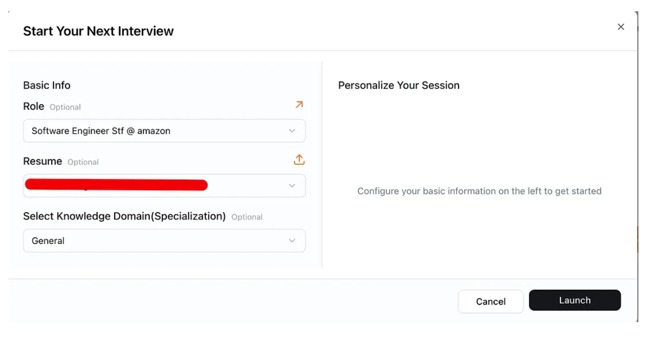
Video Functionality
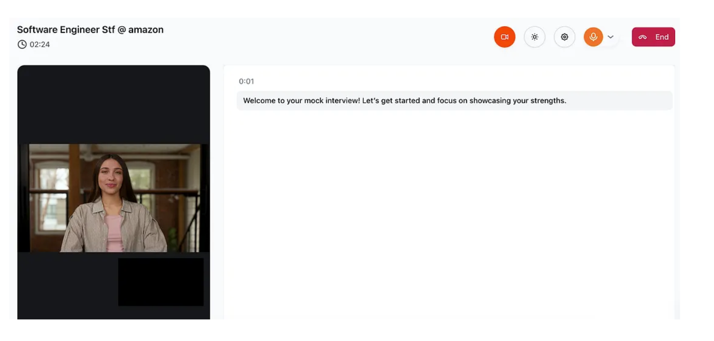

Mock Text Interview
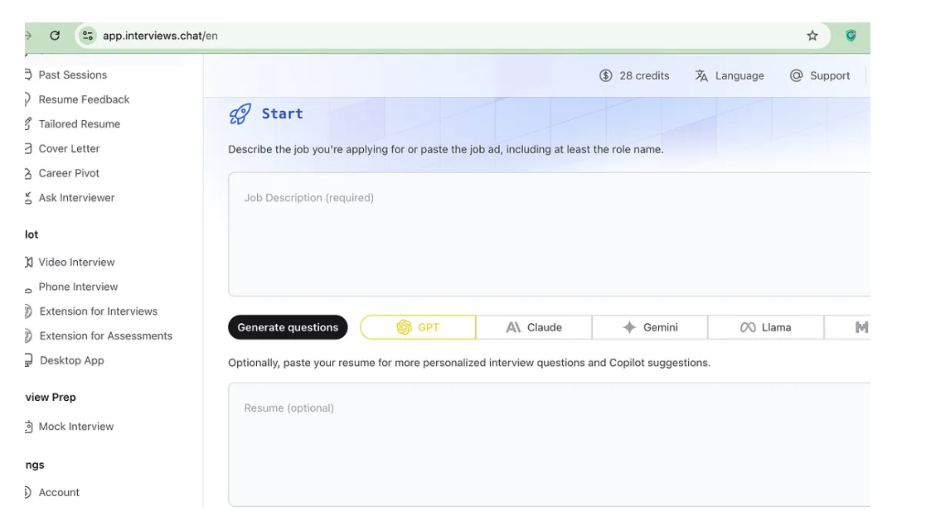

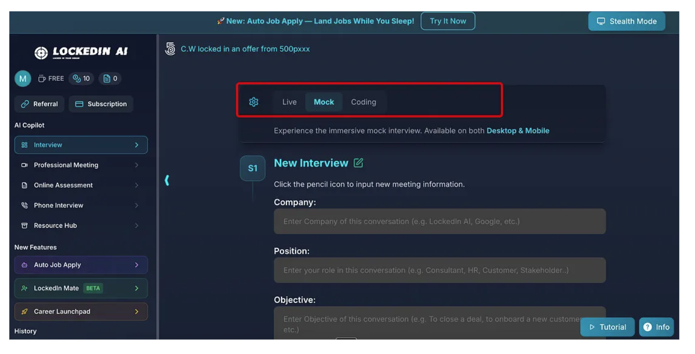

Wireframes Descriptions
Annette Wireframes 1
This design focuses on a structured interface with many features and a consistent sidebar for easy navigation. The goal of the design was to prioritize structure, efficiency, and access to core features with a persistent and playful navigation system. With this outline, users who prefer a centralized workspace where they can easily switch between key functionalists without confusion. The layout emphasizes consistency with a home screen that acts as a control to quickly begin a session, view progress, or navigation to supporting tools. Different interview session modes characterized by clickable icons and progress-checking emphasize the gamification that will set our app apart from competitors and align well with our mission to alleviate interview anxiety. This design is well-suited for users who appreciate a self-directed preparation style.
Danny Wireframes 2
This design was built to focus on simplicity, building on conventional GPT models to maintain familiarity between our website and potential users. This potential design maintains the left column navigation bar for ease of use and direction within the website. The main home is the primary function, much like other GPT models, and from there, users are able to navigate to less prominent, but still important, features of our application. The resume, schedule, and progress section receive their own section as I didn’t want to overload users with information, thus maintaining simplicity. Reports appear as a popup screen to which the user is able to save or analyze as they please. Overall, the simplicity and ease of navigation of this design allows users to focus on what’s important, building confidence and passing interviews.
Sophia Wireframes 3
These wireframes feature a sidebar navigation divided into four tabs, each having a distinct set of related features and actions. The dashboard gives a quick overview of different actions or items the user can view from the various tabs. The interface is designed to be intuitive, consistent, and clear, guiding users naturally through tasks while minimizing friction. A minimal aesthetic and structured information hierarchy keeps the experienced focused, ensuring users can accomplish their goals efficiently.
Emanuel Wireframes 4
This design focuses on a clean and intuitive layout that highlights how users interact with different sections. My wireframe emphasized structure, spacing, and hierarchy, using simple shapes (mostly rectangles) to represent key areas like navigation, content, and interactive elements. The design maintains consistency across all screens, with repeated elements like headers and grid layouts to reinforce familiarity. Larger sections represent primary content, smaller areas were for secondary features or controls. This allowed users to focus on the overall flow of the cite and how different features connect.

